**Affordable 2 BHK in Kandivali West – Your Dream Home Awaits!**

Looking for a comfortable, modern, and affordable home in one of Mumbai's most well-connected suburbs? [**Kandivali West**](https://sagarmanthan.in/) offers a perfect blend of lifestyle, convenience, and value for money. Whether you're a first-time homebuyer or looking to upgrade your space, [**2 BHK in Kandivali West**](https://sagarmanthan.in/) might just be the ideal choice for you!

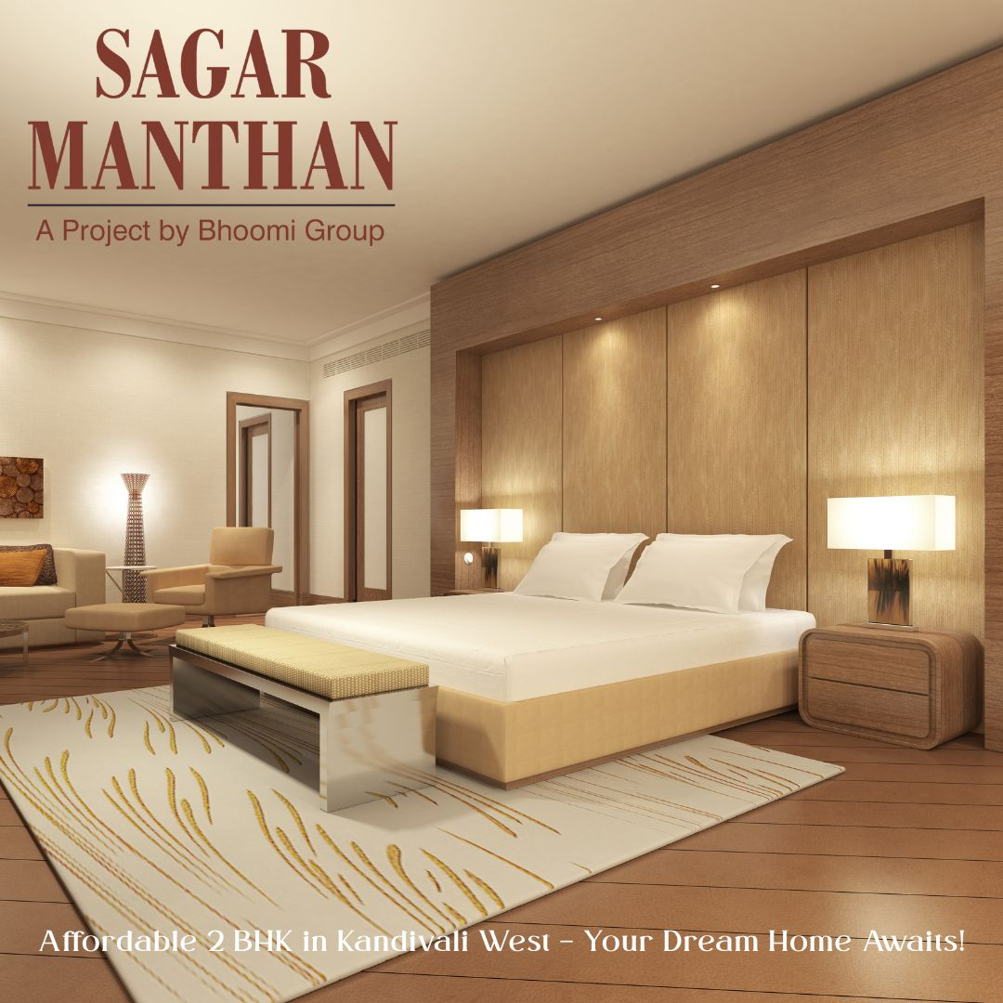

**Why Choose Kandivali West?**

[**Kandivali West**](https://sagarmanthan.in/) has rapidly evolved into a preferred residential locality for both families and professionals. With excellent connectivity to key parts of Mumbai, top-rated schools, hospitals, shopping centers, and recreational zones, the area provides everything you need within close reach.

**Key Advantages:**

* Proximity to Western Express Highway and Link Road
* Close to Kandivali Railway Station and Metro Line 2A
* Renowned schools like Oxford International & St. Joseph’s nearby
* High-end malls like Growel’s 101 and Infinity Mall within driving distance
* Peaceful residential pockets and strong community culture

**2 BHK in Kandivali West – Comfort Meets Affordability**

If you’re seeking a compact yet spacious home, a [**2 BHK flat in Kandivali West**](https://sagarmanthan.in/) is the perfect match. These homes are ideal for nuclear families, working professionals, or investors looking for rental returns.

**Features of 2 BHK Flats:**

* Carpet area between 600 – 800 sq. ft.
* Spacious bedrooms, modular kitchens, and attached balconies
* Gated societies with 24/7 security and CCTV surveillance
* Access to amenities like gym, swimming pool, garden & clubhouse
* Starting price from ₹1.25 Cr onwards

Buying a [**2 BHK in Kandivali West**](https://sagarmanthan.in/) not only gives you a place to live but also ensures long-term value due to the location’s growing demand and appreciation.

**3 BHK in Kandivali West – Upgrade to Spacious Living**

For those who need more room to breathe, [**3 BHK in Kandivali West**](https://sagarmanthan.in/) offers the extra space and luxury to accommodate a growing family or set up a home office.

**Why Opt for a 3 BHK Flat:**

* Larger living space with carpet areas from 950 – 1,200 sq. ft.
* Master bedroom with en-suite bathrooms
* Dedicated storage, study, or guest rooms
* Premium interiors, vitrified flooring, and modern layouts
* Prices starting at ₹1.95 Cr onwards

Investing in a [**3 BHK in Kandivali West**](https://sagarmanthan.in/) is a smart move for those planning a long-term stay or looking for greater comfort and style.

**Final Thoughts**

Whether you're opting for a [**2 BHK in Kandivali West**](https://sagarmanthan.in/) for its affordability or a [**3 BHK in Kandivali West**](https://sagarmanthan.in/) for its space and luxury, Kandivali West remains a top-tier destination in Mumbai’s real estate market. With excellent infrastructure, a vibrant community, and increasing property values, now is the right time to make your dream home a reality.

[**Sagar Manthan, Bhoomi Group, Charkop, Kandivali West, Real Estate Mumbai, Real Estate Charkop, Real Estate Kandivali, 2 BHK Charkop, 3 BHK Charkop, Flat in Charkop, House in Charkop, Charkop Flats, Buy Flat in Charkop, Borivali Real Estate, 2BHK in Borivali, 3BHK in Borivali}**](https://sagarmanthan.in/)

[**2bhk in charkop**](https://sagarmanthan.in/),[**2 bhk in kandivali west**](https://sagarmanthan.in/),[**3 bhk in kandivali west**](https://sagarmanthan.in/),[**2BHK in New Construction in Charkop**](https://sagarmanthan.in/),[**3 BHK in New Construction in Charkop**](https://sagarmanthan.in/),[**Buy 2 BHK in Charkop**](https://sagarmanthan.in/)

[**Buy 3 BHK in Charkop**](https://sagarmanthan.in/),[**2 bhk in kandiwali west**](https://sagarmanthan.in/),[**3 bhk in kandiwali west**](https://sagarmanthan.in/),[**3bhk price in kandivali**](https://sagarmanthan.in/),[**Buy 2 BHK Flat in Charkop**](https://sagarmanthan.in/),[**Buy 3 BHK Flat in Charkop**](https://sagarmanthan.in/),[**2 bhk under construction kandivali west**](https://sagarmanthan.in/), [**3 bhk under construction kandivali west**](https://sagarmanthan.in/), [**3 bhk in charkop**](https://sagarmanthan.in/), [**2 bhk flat price in kandivali west**](https://sagarmanthan.in/), [**3 bhk flat price in kandivali west**](https://sagarmanthan.in/), [**2bhk price in charkop**](https://sagarmanthan.in/), [**3bhk price in charkop**](https://sagarmanthan.in/), [**2bhk price in kandivali wes**](https://sagarmanthan.in/)**t**

**Sagar Manthan,  
Plot No. 213, RDP 8, Sector 4, Part-II  
Opp Saraswat Bank, Charkop,  
Kandivali (W), Mumbai- 400067.**

[**sales@bhoomiassociate.com**](mailto:sales@bhoomiassociate.com)[**+91 98191 44789**](tel:+91%2098191%2044789)[**+91 98192 44789**](tel:+91%2098191%2044789)[**+91 86928 44789**](tel:+91%2086928%2044789)